PATTISON Outdoor Advertising and Toronto Pearson partner to usher in a new era of airport experience
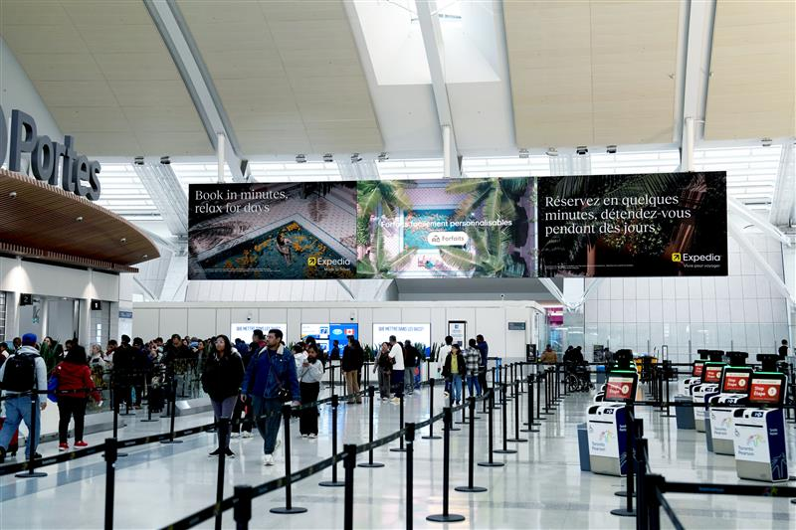
MISSISSAUGA, ON, January 21, 2026 - PATTISON Outdoor Advertising is proud to announce a landmark 10-year agreement with Toronto Pearson, naming PATTISON the airport's exclusive advertising and brand experience partner.
As Canada’s leading out-of-home media company, PATTISON leverages decades of expertise in media innovation and flawless execution. Through this partnership, both organizations are dedicated to redefining the passenger experience and cementing Pearson’s position as a premier global media destination.
PATTISON is committed to operational excellence and delivering results through its proprietary airport media planning and audience analytics tool — PATTISON Pulse — which will provide first-to-market consumer data, analytics and insights. This tool, among other technology innovations, will allow advertisers to optimize their media buys to create experiences that are targeted, impactful, and relevant to passengers.
In addition, PATTISON enables brands to gain an in-depth understanding of the airport environment through the deployment of interactive digital twins that include mapping capabilities, coupled with dynamic content and advanced targeting. The introduction of smart technologies, paired with innovative media placements, will further enhance the passenger journey. With a proven track record of managing high-traffic public environments such as airports and transit, PATTISON’s reputation as an exceptional partner, committed to transformation, service and maintenance, creates strong synergy with Toronto Pearson’s goal of delivering a world-class passenger experience.
“It cannot be overstated how important and impactful the partnership between PATTISON and Toronto Pearson is for the Canadian advertising and aviation landscape. PATTISON is embarking on this journey with a steadfast commitment to long-term growth and innovation, delivering the very best in media technology to create a seamless travel experience, while empowering brands to connect with highly coveted audiences in an environment where they are most receptive,” said Steve McGregor, President of PATTISON Outdoor.
“Collaborating with PATTISON allows us to elevate how passengers experience Canada’s largest airport,” said Kurush Minocher, Chief Commercial Officer, Toronto Pearson. “Through advanced media, smart technology and thoughtful design, we are creating a more seamless, engaging and memorable journey for every traveller as Toronto Pearson continues to grow as a world-class global hub.”
With a renewed focus on delivering meaningful, passenger-first experiences, media upgrades will take place over the course of the partnership, with all enhancements centered on design innovation. The partnership will not only enhance interior airport spaces but also include an expanded exterior program.
Through this forward-looking strategic partnership, Toronto Pearson and PATTISON Outdoor Advertising will strive to set a new global standard in airport advertising and brand experience.

-30-

About PATTISON Outdoor
PATTISON Outdoor Advertising, a division of The Jim Pattison Group, is Canada’s largest Out-of-Home advertising company. PATTISON helps brands and businesses harness the power of Out-of-Home advertising by providing the most comprehensive range of products, markets, insights and customer support services.
With roots dating back to 1908, PATTISON has been providing innovative solutions for Out-of-Home advertising opportunities with products ranging from traditional billboards to transit, digital, airport, residential, office, and street-level formats. PATTISON is headquartered in Toronto, Ontario, with over 25 sales offices across the country, providing advertisers unmatched reach and coverage with products available in over 200 markets coast to coast.

